Celtic Warrior Full Ironman (01 Aug 2020)

I’ll start this report by saying I had absolutely no right to be on that course on Saturday. Although I had done some training during lockdown, it was nowhere near what it should have been. And, really, I should have had my @ss handed to me that day. And, if it wasn’t for the support of amazing friends and clubmates, it probably would have been.
I had reasons to do this event, and my reasons outweighed my lack of training. I know some thought me mad – and it was a bit. Ok, maybe a lot! But if there was anywhere it could possibly be done, it was going to be at Celtic Warrior. The ‘no pressure’, ‘no deadlines’, family-friendly weekend event. It has to be the best hidden triathlon gem in Ireland. And it really should be more heavily subscribed. It’s a phenomenal location, event and atmosphere.
My Celtic Warrior weekend started on Thursday. The plan was – head down to camp on Thurs, do support crew for Eamonn on Friday, race on Saturday, party Sat night (ha, that was optimistic!!), then support club mates in their events over rest of weekend.
Packing the car with gear felt like a game of Tetris. Loading up for 4 nights of camping with a race in the middle was much worse than loading for a week’s holidays for a family. I had a list – just to make sure I didn’t forget essentials. But this list is never the definitive list. As I pack, I find other stuff to pack that I think I ‘might’ use. Needless to say, I didn’t use half of it!!
Well, support crew duties didn’t take long to kick in, when I get a call early afternoon, before even leaving Athy. Someone had forgotten his bike shoes. Support crew duties dutifully fulfilled by picking up said shoes before heading up to Lilliput.
Arrived at Lilliput around 4pm. Eamonn there and his tent up already. Impressive stuff, considering the disaster back garden trial run he’d done a few days prior.
Pitched my own tent a bit later when Ger (Prendergast) arrived. No drama with set-up, cos I’m a pro! (Not a pro!! But heaven forbid I’d show myself up in front of Eamonn and Ger!!) Once everyone was sorted, we headed to Kilbeggan to grab a cup of tea before heading to bed in preparation for an early start on Friday.
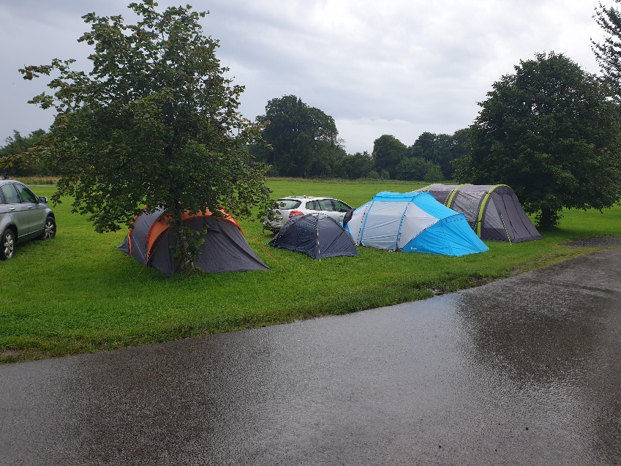

Fri morning:
Wake up at 4.30. Time for breakfast and the lads get ready to get in the water for 6am. Beautiful sunrise over the lake, lake calm. Perfect start.
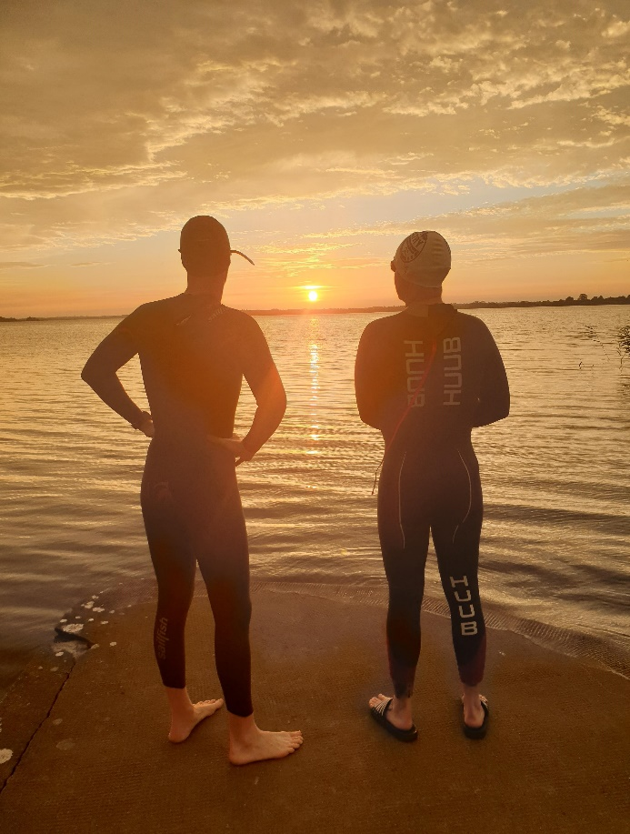
Into the water and off they went. Bike nutrition brought down to bike route – time to chill before they’re back out of water.
I had agreed to do one loop of bike with them. They were out of the water in really good time. Weather forecast was not looking good for the bike – rain forecast. Started to drizzle at start of bike.
Ger (aka speedy speedy) was setting a blistering pace. Trying to keep up with the two of them had my heartrate right up. Glad I was only doing one loop (30k). I’d forgotten some of the drags, so it was useful to get the reminder ahead of Saturday’s race. I was very happy to be taking a left after that first lap, to head back to base camp. It made me nervous, if I’m honest. Nervous because I felt beat after just that one loop.
AAAAND.. fekin garmin told me I needed 4 days recovery after that effort! FOUR DAYS!!! FFS, how unfit am I?! And just how was I going to do that bike loop 6 times the following day.
It was just as well I had to get back into support crew mode, cos I’d have driven myself demented dwelling on that nugget.
I drove the car down to the food stop point for lap 2 and lap 3 of the lads bike. Nothing needed by either for lap 2. A nice hot cuppa tae provided for lap 3. There had been torrential downpours all through that bike part. So much so, wringing out of socks midway through bike was like watching a waterfall. Ger came in to base camp for one of his famous smoothies at lap 4. Eventually, after a tough, wet bike, the lads were in and getting ready to do the marathon.
Here is where there was demonstration of pure will and determination. The run turned into a bit of a struggle for Eamonn. You could see the pain in his face, but still determined to just not give up. One thing he keeps beating himself up about is how he isn’t where he wants to be w.r.t. fitness. But, this guy has come back from over a year of stuff that would make most people throw in the towel. To be able to do this, to be willing to do this, is nothing short of phenomenal. I got to walk one of the laps with him. As much as it went against the grain for him to walk a whole lap, he did it knowing it was the best thing he could do to regroup, settle HR, settle head and finish this damn thing. And finish it he did.. strong and proud with Jack! And this is why I admire this guy so much. He’d make you believe anything is possible. And how’s that for a legacy to give your kids?! A ‘never quit’ attitude, showing you can do anything you put your mind too. I love that!
Support crew duty done, it was time to psych myself up for my own effort the next day.
Double checking of equipment, food supply, drink, etc in my tent, I hit the hay and attempted to get some sleep.
I reckon I got about 4hours. Got coffee in the local garage to wake up the body and it was time to rack up.
ATC accounted for half of the full Ironman race entry.. yep, 4 ATC members out of 8 racers. Eamonn, Rob, Anna and myself. I was under no illusion – I knew this was going to be a tough day, this was going to hurt. I wasn’t properly trained, so I had no expectations. All I wanted was to cross that line – to prove to myself that I can be strong when I want to/need to be. That I can do something I put my mind to.
Some will know that I’ve had a bit of a rollercoaster over the last while. So, this was also a kind of ‘line in the sand’ moment of leaving that all behind and moving forward. Focus on the positive, surround yourself with good people, be good/kind to yourself and believe in yourself.
Getting set up this year was a far cry from 2018. Back in 2018, I was SUCH a nervous wreck. You couldn’t talk to me. This year, although there were still nerves, without the pressures of time (Celtic Warrior is sooooo laid back!) and the knowledge that I had no right to have any personal time expectations, I felt ok. Didn’t stop me fussing about in transition, but why break the habit of a lifetime! I knew that my ankle could cause me problems during run, but I didn’t dwell on that and decided to just deal with whatever comes my way, instead of worrying about the ‘what ifs’. Another big life lesson I’ve learned over the last year or so. Take each day as it comes because worrying about what might be just takes away from living in the moment. No one can predict the future, so why ruin a good day by worrying about something that may never happen. And I was right not to worry.. ankle never bothered me at all… the pain was everywhere else.. ha!

Anyway, moving on…
Racked, transition area ready, beat into my wetsuit, it was down to the lake to start the swim. The water was just lovely. For the first 3 laps, my goggles kept misting up, so I had to stop and fix on each lap cos sighting was impossible through them. It eventually settled after that, thankfully.
I’m not a great swimmer. I’m not shit, but I’m not great. What I am shit at is sighting. Holy sweet jesus, the amount of weaving I did. It was a 5 loop course, and what should have been 3.8k, ended up being 4.7k for me. I added nearly 1k to my swim. Causing me to be in the lake for 1hr 30. Oh well, nothing I can do about that now. Saw Eamonn waiting at end of swim so we headed into transition together. Felt ok. A bit pissed at the time wasted weaving, but soon let that slide and got ready for bike. At this point, more of the ATC crew were setting up for the half iron event. Bernie, Lara, Caitriona, Arno. So that was cool – loads of shouts of encouragement, bit of banter. Dried off, bike gear on, bite to eat and it was out of transition and on to the road.
The plan (before Friday!) was to average about 25k/h. After doing that on one lap on the Friday, that was out the window if I had any chance of finishing. So, the plan was to go by HR and hope for a decent pace. I was conscious that the 25k/h plan was made with Eamonn, and to go slower could have a negative effect on his own personal goal this weekend. The amount of times I told him that he should go on ahead, that I have to stick to my own (slower) strategy now and that if he wanted to come in under 17hrs, he’d need to leave me. To his credit, he stuck with me right up to lap 5 – allowing me draft his back wheel for portions. Allowing my HR to settle again and keep going. After that, he headed off. Thank fek – cos if that f***er didn’t come in at a respectable time, I’d never hear the end of it! :P
Lap 5 and 6 solo – I kept my HR steady. But for the first half of lap 5, my stomach started acting up. I thought I was going to have to stop the bike and puke multiple times. I stopped eating and only drank water. That seemed to do the trick. Coming to end of lap 5, stomach had settled but legs were hurting. And there was no doubt I was getting slower and headwind seemed to be getting worse. As I came in to Lilliput after finishing my last lap, I could see my trio at the corner where the road turns into Lilliput. That put a smile on my face and I shouted out to them to follow me up so they could do a little run with me. Finished bike in approx. 8hrs 10ish mins. Garmin says 8.21, but I forgot to register transition.. d’oh.
I totally took my time in transition. The half warrior crew were done, so had a bit of banter with them. Padraig, Arnold and Donna had made the trip to support as well. So, so good to see them. Swear to god, love this club. Everyone is always rooting for their club mates and are there supporting whenever they can. You can’t beat it.
I could see my little men making their way to transition. Puffing and panting to get to me. The run from the corner up to transition proved too much for two of them.. so I just had Cian come join me on the run. Well, a walk really, as the poor pet had run all the way to transition from the run turn corner into Lilliput. No mean feat for an 8yr old.. Off we went on our little walk. I LOVE LOVE LOVE these moments with my little men. The one-on-ones are especially wonderful. Cian was just so happy to be out on the course, after seeing the buzz of the race, the support of clubmates. It’s just such a positive, fun atmosphere that can only be good for the kids to see. We were chatting loads on the way around. He had to turn back a short way in, but I’d had a lovely few moments with him until then. Enough to make me feel good, and set me on my way.
Lap 1.. after Cian headed back, I went on and out onto the road for the first lap. Time to turn on the pumping tunes. I was going to listen to the tunes I used for training for Barcelona 2018. They’re proper positive boosting tunes for me. I love them.. they get me pumped and ready for anything. Outward bound and I see Anna, Rob, Ger and Eamonn – all looking strong. Feeling good, nearly on a bit of a high. Might have been something to do with being off the torturous bike too. Either way, it was all good.
As I was heading to the first turnaround point, my boys went by me, so I managed to get another quick cuddle and chat with my munchkins before they were on their way and I turned to head back and finish loop 1 of the 8 and half loop run. I was feeling really good. Surprisingly good. And, for the first time that day, I was thinking this could actually be a nice enjoyable and doable run/walk. I even called my sister during the walk part of the first lap – as you do, like!
Feeling good - oh how the mind can lull you into a false sense of security.. haha!
Lap 2… still feeling good. Pace slow but steady. I was looking at the clock and thinking if I could maintain this pace, I’d definitely make it in within the 17hrs. I think it was this lap that Eamonn came up behind me, lapping me. Big reassuring hug from the guy who’s been a frickin’ rock to me these last few years. He’ll prob be morto me saying this. But I know I wouldn’t have been at that starting line on Saturday if it wasn’t for him. He’s been a rock solid bestie that I’ve leaned on so much, and he’s never let me down. As well as giving me a kick in the @rse when needed. This race was no different. A legend – puts on a tough exterior, but he’s got the biggest heart. He’ll kill me for ruining his rock hard legend reputation now.
Lap 3 .. ok, this was starting to hurt.. and the mind was starting to wander. Coming in to finish lap 3 and just coming up to the ATC run aid station, the floodgates opened and I started bawling. Zuzana and Colin witnessed the meltdown – sorry guys! And Zuzana just jumped out beside me and started walking with me. Within minutes the waterworks stopped. Walking/jogging and chatting with Zuz took my mind off myself and what I was doing and got me through the next while. From here on the laps blur into each other, so I couldn’t tell you what number lap each of these things happened. But my abiding memories of the rest of the run are as follows:
Zuzana basically becoming my full on support crew. The weather had turned, the rain had started. I was getting soaked to the bone. Knew I had dry tops and socks in my transition box, and a rain jacket in my tent. Zuzana grabs my rain jacket (that’s not waterproof, as I was to find out ) as I head on to transition to change my top and socks. I arrive in transition, only to find the lid of my gear box off and all contents inside wet. One of the tshirts wasn’t as wet as the one I was wearing, so thought putting this on was at least better than leaving a wetter one on me. The socks seemed ok though, so that was a relief. Blisters were starting on the soles of my feet and this would at least prevent them getting too much worse. I promptly put these on before heading back out on the course again. During the transition stop, the timing guy was asking what lap I was on. Seemed odd, as surely he’d be clocking each time I cross the mat. But no, my timing chip wasn’t registering, so I’d find myself announcing my arrival every time I crossed the timing mat each lap. It was actually fun, heralding my own arrival and getting a nod/thumbs up from him and a small positive comment to send me on my way again. Obviously he could tell from the lap I was on that this was going to be a late night for us all! After changing, I was off again. Zuzana, I think you came with me again on the next lap too – carrying drink and food for me and dishing out the BEST TASTING choc chip biscuit EVER. Swear to god, you’ve no idea how much that support meant to me. As we were walking through this lap, I was feeling so guilty dragging her around AGAIN. But I didn’t know how I would say it, without sounding ungrateful. Eventually, at end of this lap I said that I wanted to do the next one alone. Said I’d turn on the tunes again and get myself pumped. Total lies, but it meant Zuzana could have a break. So, off I go again – I turn on the tunes, but I don’t get pumped, I get ridiculously emotional. I was in real pain now. From my ribs to my toes. I actually touched my ribs and they were tender to the touch. No idea how or why. I’d never felt this before. My quads were on fire, but I blame that on my ‘out of saddle’ hill climbing through the bike. They would have been harder on the legs than just sitting and toughing it out. I was now paying the price. My ankle – the one thing I truly believed would be my downfall – was about the only part of me that didn’t hurt! Go figure!
Anyway, a particular song from the Barca playlist came on – ‘Superheroes’ by The Script. Well, I bloody well bawled and bawled and bawled listening to the lyrics.
Shortly after, I was on the way back from turnaround point and just as I was coming up to the point where the outbound run path joins the road, I see three people walking my direction. It was Eamonn, Colin and Zuzana. Well, I just fell apart.. I remember muttering something to the effect that ‘I can’t be left alone’ – what I meant was, that every time I was on my own since mid-marathon, I was falling apart. It didn’t mean someone had to come with me (and I hope it didn’t seem that way either). But Zuzana left Eamonn and Colin to walk with me on the way back. I was a goddamn mess. I bawled on her shoulders. I’m a sap at the best of times, but I honestly believe these events, especially the longer ones, have to be the most emotion-ridden rollercoasters I’ve ever experienced. In a perverse way, they’re kind of therapeutic. A counsellor would probably be cheaper, but I’m a sucker for punishment! So, once again Zuzana selflessly walks with me, distracting me, chatting about Rosie, her new little kitten, showing pictures. Like magic, I was feeling sane again. She came with me for another lap too. Again I was starting to feel guilty about her walking with me cos she had, by end of lap 7, walked a half marathon with me. Never once complaining. I felt terrible. I told her coming to the end of lap 7 that I would finish this out on my own. That I was doing fine now and I’m nearly home. Plus she had to get back to Athy and get to bed. That girl hadn’t even slept the previous night. She had gone above and beyond for me and I will never forget it.
Weather was getting worse and worse now though. My rain jacket, that wasn’t a rain jacket, was soaked through. I was soaked to the skin. I was shivering now. Really goddamn cold. Zuzana had already given me her hat, back at transition she grabbed me her ‘really waterproof’ fishing jacket from her car, a torch from my tent. It was getting pitch dark. Baco was still standing under that ATC tent. As I was telling them I was grand now and on the home stretch, Baco went into concerned mode saying he’d follow behind in his car. I told him I’d be fine. I had my torch, I was fully protected from rain now too, so the rest would be fine. I headed on out through transition, telling Vincent (Mr. Timekeeper) triumphantly that I was on my last big lap! Off I went, walking through Lilliput again, before reaching the road. On that little path, with the rain and the darkness there were SOOOO many little frogs just jumping across the path in front of me. It almost felt like I was hallucinating cos I could see so many. That made me giggle a bit before I hit the road part of the 5k loop again. Maybe I was going mad!
As I was walking that dog end, I was talking to myself, reminding myself why I was doing this. Who I was doing this for, what I was doing it for. It was a surreal kind of experience. Walking that road, spilling rain, torch in hand, there was Baco behind me with car lights lighting the way. When I turned that turnaround bollard for the last time that night, I left some choice words, statements and tears there – a bit of a release of months/years of emotion. That bollard was my ‘line in the sand’ – never to be seen again!!
So, I’m coming back now.. coming up to the corner that brings me back into lilliput and I see lights in the distance. I wasn’t sure, but I had a feeling I knew who it was. Initially I thought it was Franky checking up on the last straggler that was keeping him from his bed.
When I realised it was Eamonn, floodgates opened again. I was sobbing. Like, proper, proper sobbing. He had finished at least 2 hours earlier. Finished B2B Ironman distances. His feet/body in tatters but he still came out to bring me across that line. I was an emotional wreck. As we were walking, I kept telling him that he should get into the car with Baco (while secretly thinking to myself ‘I hope he doesn’t, I hope he doesn’t!’). I’m sure we looked a right sight. Hobbling like 90yr olds. Laughing at the state of ourselves. He would take a veer once or twice and would later tell me that he was nearly falling asleep on his feet!! Now, imagine how it felt for me to know that I had someone who had just done what he had done, was broken up physically as a result of his B2B, but still was selfless enough to come back out to bring me across that line, knowing how much it meant to me. Course I was an emotional mess. How could I not be?!
Baco lit the whole way home in his car, driving at probably (at a stretch) 5k/h. Another ATC legend and true team supporter.
Crossing the line and Vincent did the official clock stop as I crossed the line just after midnight. Time clocked in at 17hrs 51mins. Even that post-midnight crossing felt kind of epic. I don’t know why really, but it did. In any official Ironman race that time would have meant I was disqualified (17hrs is the standard cut off). But I don’t feel like I didn’t achieve something. Saturday was fully loaded with emotion, displays of true friendship, battles (mental and physical) and accomplishments. I will NEVER EVER forget it as long as I live.
I love this sport, I love our club and I love and cherish the friendships I’ve made through it all. Joining ATC was a life-changing decision for me. One I’ll never, ever regret.
I collected my plaque, hit the tent for bed. Took me the longest time to get changed and into the sleeping bag! The party would have to wait until Sunday.
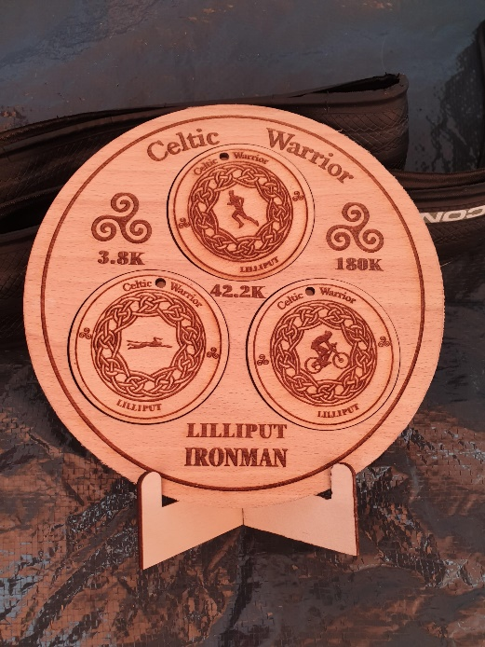

This Celtic Warrior weekend was one I will always remember. I don’t think even writing this report does justice to the whole experience. It’s so hard to put feelings down in words.
I’m definitely making this an annual thing. And I hope it turns into an ATC away event every year. It can’t be beat for location and atmosphere. And having the ATC family there is just the icing on the cake.

